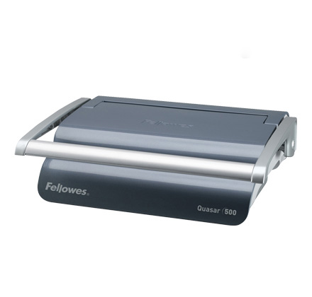

**Binding**

**Machine**

**Instructions**

**If after reading these instructions you need further guidance,**

**please ask a member of library staff.**

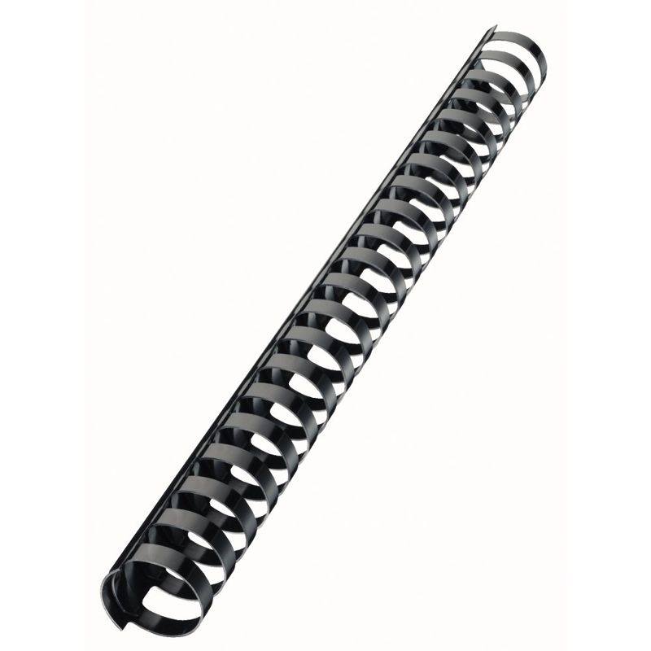

**HOW IT WORKS**

**Binding comb**

Ask staff at the issue desk for a binding comb and

clear plastic/card cover sheets (**50p** per set)

**QUICK GUIDE**

1. Place comb in machine, open comb.
2. Punch holes in sheets, in bunches of **not more than** **10** pages or **2** plastic sheets.
3. Load sheets onto comb in batches as they are punched.
4. Release comb to finish binding.

step-by-step guide on the following pages

Trouble-shooting guide at end of manual

**LEVER**

**LID**

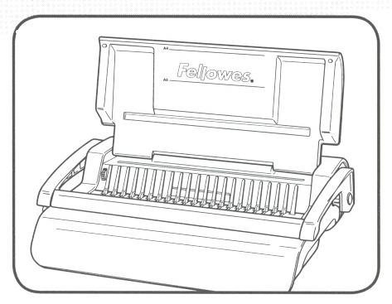

**INSERTING THE BINDING COMB**

**HANDLE**

**TEETH**

1. Lift the lid and handle.

**TEETH**

1. Check lever to side is fully pushed back.

**HANDLE**

1. Place the binding comb behind the row of silver teeth

with curls opening up toward the top; comb rings

should go between the teeth.

**FRONT OF THE MACHINE**

1. Pull lever gently towards you to open

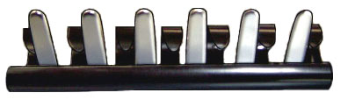

the comb (do not pull it too far!)

**LEVER**

**VIEW FROM BEHIND TEETH**

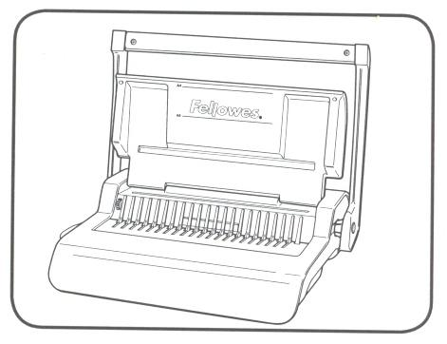

**WITH HANDLE LIFTED**

1. Only punch **10 sheets of paper** or **2 plastic sheets** at a time

**PUNCHING THE HOLES**

– more will cause a jam!

2. Lift handle.

3. Insert sheets into slot towards the back of the machine

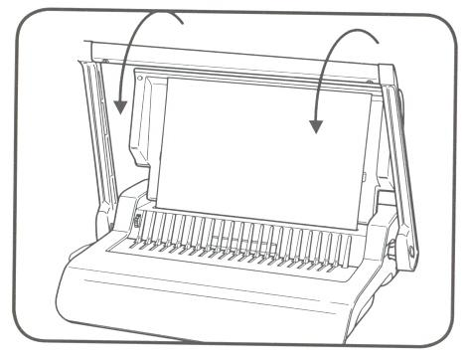

(alongside the black dotted line, which indicates where the

hole punches will be). Make sure the papers are as far in

and as far to the left as possible.

4. Pull down handle.

**HANDLE**



5. Return handle to upright

**PAPER**



position to release pages.

6. Remove pages.

**BINDING THE SHEETS TOGETHER**

1. Place the batches of paper on the comb as they are punched to keep them in order and keep all the holes aligned

(if applicable, remember to start and end with your cover sheets).

1. Once all sheets are placed in the comb push back lever to original position to release completed document.

**PAPER**

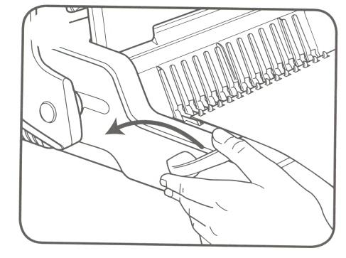

**LEVER**



**HAVING TROUBLE**

**Binding comb doesn’t open:**

Try turning the binding comb over so that the curls open up *toward the top* and the comb is *behind* the teeth. Make sure the lever to the side of the machine is completely pushed back before inserting comb.

**FRONT OF THE MACHINE**



**CURLS OPEN UP TOWARD THE TOP**

**COMB IS BEHIND THE TEETH**

**VIEW FROM BEHIND TEETH**

**Crooked punch-hole line:**

Try placing the papers in the entry as evenly as possible and pushing them in and to the left as far as possible. Otherwise ask library staff to clean out the paper scraps that fall into a tray at the bottom of the machine (see next page).

**Stuck handle / paper jam:**

DO NOT tear out the paper. Push down on the handle as hard as possible and as many times as necessary to clear the jam. Try punching smaller batches of paper.

**Clearing out the paper entry:**

Take a ruler or stiff cardboard and slide it into the paper entry, moving it back and forth to release paper cuttings into the waste drawer. Empty the waste drawer, which is accessed via the right hand side of the machine.

**The last hole goes off the edge of the paper:**

Make sure you line up the sheets of paper with the purple edge guide. This can be set to either A4 or A5 by rotating the purple dial. The black broken line on the machine indicates the position of the hole punches.

If you continue to have problems please come to the

issue desk to ask a member of staff for help