KLUWER ARBITRATION

ACCESS | Available online. Access via OxLip+.

SEARCHING
Advanced search | - Select advanced search from the top right of the page.  - Complete the search boxes using the drop down menus, where provided, to select.  - The free text field searches for terms anywhere in any text in the database.  - Refine your search by combining a free text search with options further down the page.  - The database automatically searches all content categories. Select a specific category to restrict your search.  Note: the Organization field searches for documents issued by a national or international organization, not about the organization.  Note: the search function does not cover BITs.
Browsing | - Use the tabs on the top of the screen to browse documents.  - Headings within each category are hypertext links – select the appropriate headings to find relevant documents.

SEARCH CONNECTORS | - Use the drop down menus next to each search field to select and, or, not to combine search terms.

RESULTS
Viewing | - Results are listed in reverse-chronological order.
Navigating | - From the results list, selecting the title opens the document for viewing; the second highlight search link takes you to the highlighted search terms within the text.  - Click on the highlighted term to take you to the next occurrence of the term.

PRINTING & DOWNLOADING | From the full text, select the printer icon at the top of the document. The document will display in a new window which can then be printed or downloaded as usual.

The Home Page

Browse books by title, author or year
Browse the website’s content in the ‘browse categories’ box or tab
Browse journals

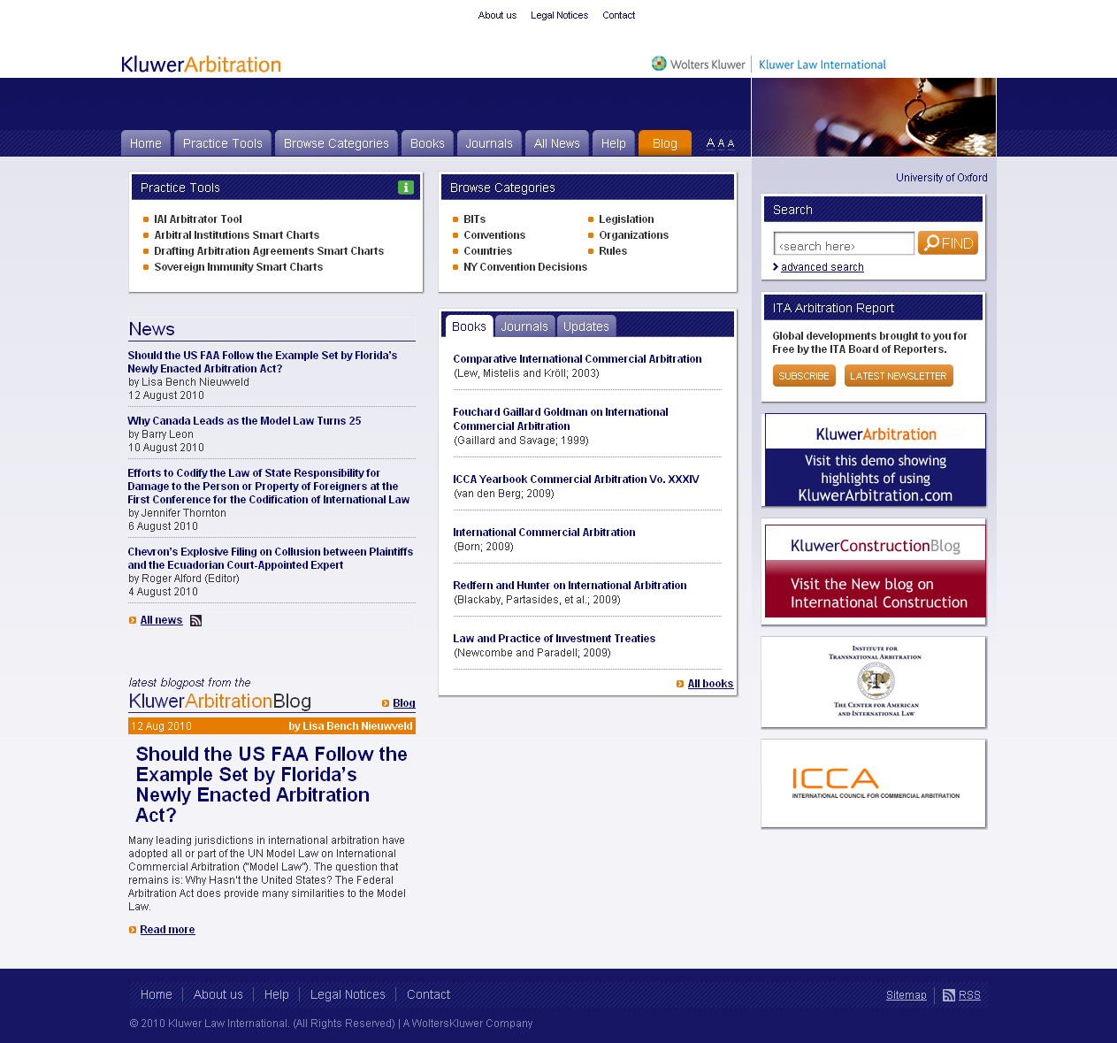
Search across all material in database

Review all recently added material

Follow the Kluwer Arbitration blog here

Read the latest news and blog posts

How to Search

Complete the relevant fields – combining a free text search with other search options will narrow the search for you

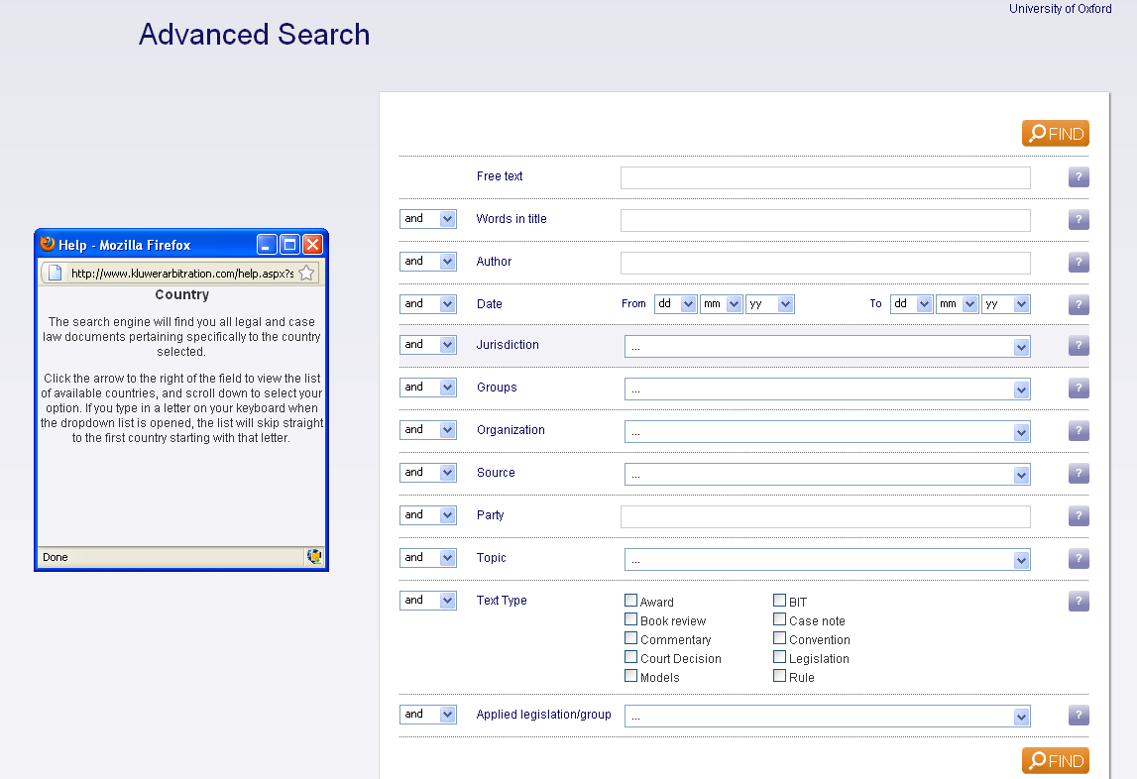
Use drop down menus to select and, or, not

Use the ‘question mark’ icon to get help on each search field. A pop-up window will display further information

Narrow the content you want the database to search through

What to do with the Results

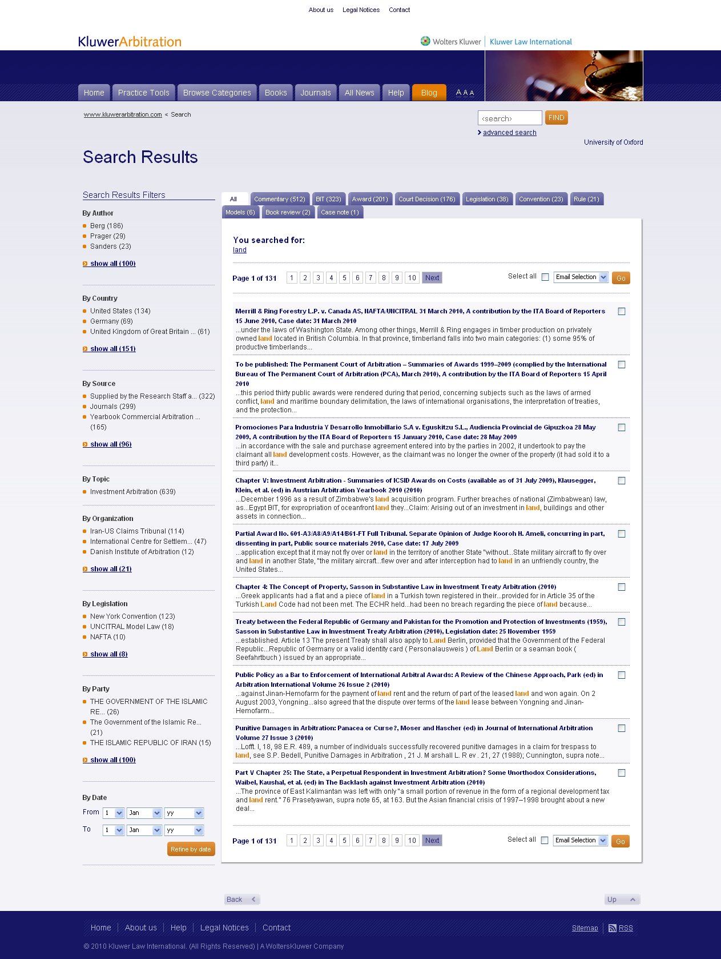
Print or email any of the results by checking the relevant box and choosing ‘email’ or ‘print’ from the drop down menu
Refine search by using search filters on left of form

